

UNIVERSITY OF ASIA PACIFIC

**Object Oriented Programming II Lab: Visual and**

**Web Programming Lab**

**CSE – 310**

**ER Diagram and Schema**

**Dept. of CSE**

**Submitted To:**

Md. Nahiyan Uddin

Lecturer,

Department of CSE

University of Asia Pacific

**Submitted By :**

Name: Ferdous Alam Naeem

Id: 18201035

Name: Ferdous Alam Naeem

Id: 18201035

Name: Ferdous Alam Naeem

Id: 18201035

**E-R Diagram**

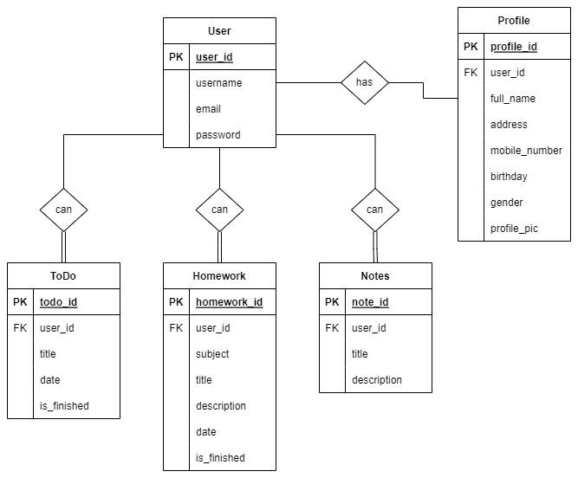

**Schema**

**User**(user_id, username, email, password)

**Profile**(profile_id, full_name, address, mobile_number, birthday, gender, profile_pic)

**Notes**(note_id, title, description)

**Homework**(homework_id, subject, title, description, date, is_finished)

**ToDo**(todo_id, title, date, is_finished)